

**LA GRANDEE INTERNATIONAL COLLEGE**

**Simalchaur, Pokhara Nepal**

A Project Proposal On

**“Mind Mend”**

### Submitted to:

La Grandee International College Bachelor of Computer Application (BCA) Program

In partial fulfilment of the requirements for the degree of BCA under Pokhara University

### Submitted by:

|  |  |  |  |
| --- | --- | --- | --- |
| **Name:** | **Course** | **Semester** | **P.U. Registration Number** |
| Sapna Baniya | BCA | 8th | 2018-01-53-0129 |
| Nabaraj Poudel | BCA | 8th | 2018-01-53-0116 |
| Mahima Sharma | BCA | 8th | 2018-01-53-0113 |

### Date: May-8, 2023

**Table of Content**

1. Introduction 1
2. Problem Statement 2
3. Objectives 3
4. Methodology 4
5. Design 6
   1. Class Diagram 6
   2. ER Diagram 7
6. Gantt Chart 8
7. Deliverables 9
8. References 10

**List of Figures**

Figure 4. 1 Agile Methodology 4

Figure 5.1. 1 Class Diagram 6

Figure 5.2. 1 ER Diagram 7

Figure 6. 1 Gantt Chart 8

# Introduction

MindMend is a mobile application designed to help individuals manage their mental stress and well-being. This app provides support and tools for people who are struggling with anxiety, stress, and other mental health issues.

One of the main features of MindMend is Meditation and mindfulness exercises and its mood tracker, which offers a variety of guided meditations and mindfulness exercises that can help users to reduce stress and anxiety, improve focus, and cultivate a sense of calm and also allows users to monitor their emotions and track their moods over time. This can be helpful in identifying patterns and triggers that may be contributing to their mental health issues, and in developing coping strategies to manage these challenges.

The app also provides community support which includes a community feature that allows users to connect with others who are also using the app. This can provide a sense of support and accountability, and allow users to share tips and strategies for managing stress and anxiety.

Overall, Mind Mend is a valuable tool for anyone looking to improve their mental stress and well-being. With its range of features and user-friendly interface, it is a great choice for those who are new to mental health management, as well as those who are looking for additional support on their journey towards better mental health.

# Problem Statement

Mental health issues such as anxiety, depression, and stress are prevalent in today's world. People often struggle to find adequate support and resources to manage their symptoms.

* Traditional therapy can be expensive and time-consuming, making it inaccessible to many individuals.
* Additionally, many people may feel hesitant or ashamed to seek help due to the stigma associated with mental health issues.
* Many individuals experience challenges in finding effective mental health resources that cater to their specific needs and preferences. This can lead to frustration, confusion, and a lack of progress in their mental health journey.

The MindMend app aims to address these issues by providing an accessible and affordable platform for individuals to receive mental health support. The app offers a range of features such as mood tracking, guided meditations, journaling, and connection with other communities and friends. By providing these tools and resources, the app hopes to empower individuals to take one step ahead towards improving their mental stress.

# Objectives

The main objectives of this project are:

* Creating a community-driven platform for peer support and mental health advocacy.
* Providing a platform for individuals to improve their mental health and well- being through various features
* Promoting mental health awareness and education to reduce stigma and increase understanding.
* To help user to analyse their thoughts and track their mood
* To recommend different exercises and workouts according to user’s mental status.

# Methodology

In this project we are using Agile Model for the development of our project. The diagram of iterative model is shown below:

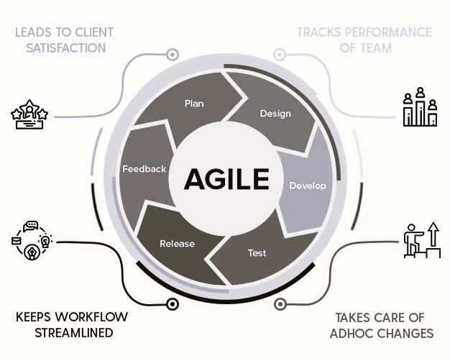

Figure 4. 1 Agile Methodology

Agile methodology is a popular approach for software development, and it can be a good fit for developing MindMend. One of the main benefits of Agile methodology is that it allows for changes and updates to be made easily throughout the development process. This is important for an app like MindMend, which may need to adapt to user feedback or changing market conditions. Other advantages of using Agile methodology for the development of our project are:

* Flexibility: Agile methodology allows for changes to be made to the project as it progresses, providing greater flexibility in responding to changes in user needs and market demands.
* Team collaboration: Agile methodology emphasizes close collaboration between the development team, stakeholders, and customers.
* Transparency: Agile methodology encourages regular communication and reporting of project progress, making the development process more transparent to all stakeholders.
* Continuous improvement: Agile methodology is based on continuous improvement, with regular review and retrospection of the project process and outcomes.

# Design

## Class Diagram

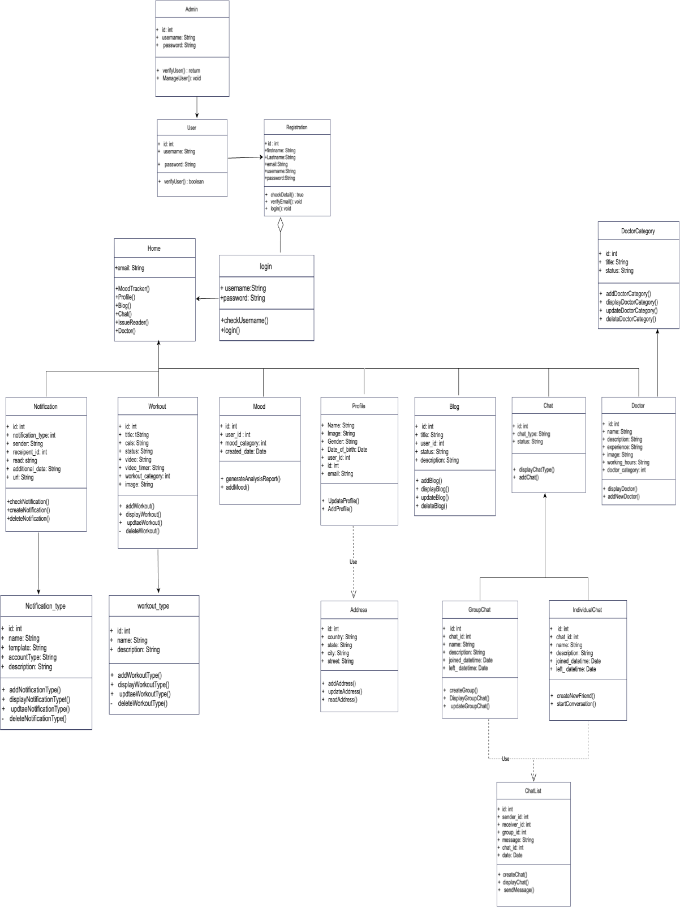

Figure 5.1. 1 Class Diagram

## ER Diagram

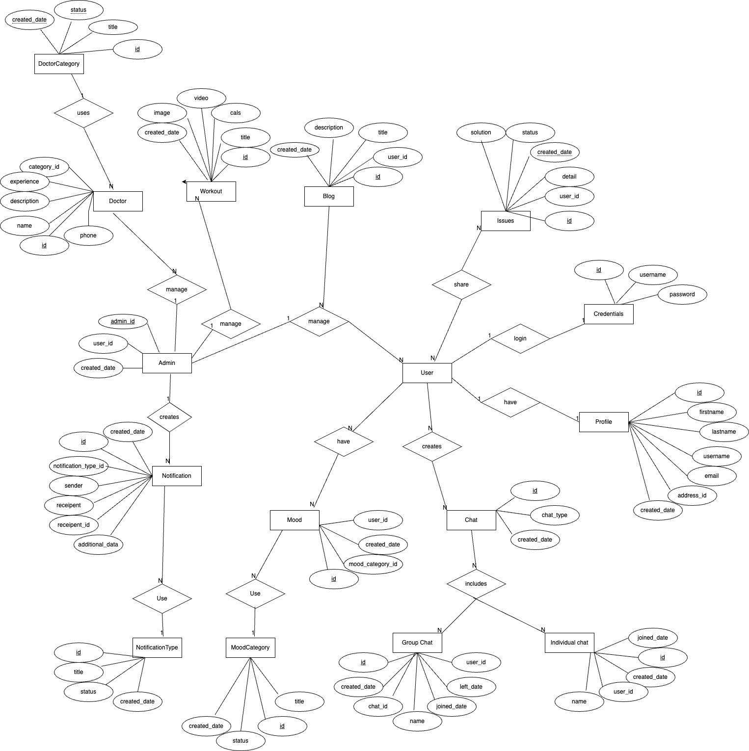

Figure 5.2. 1 ER Diagram

# Gantt Chart

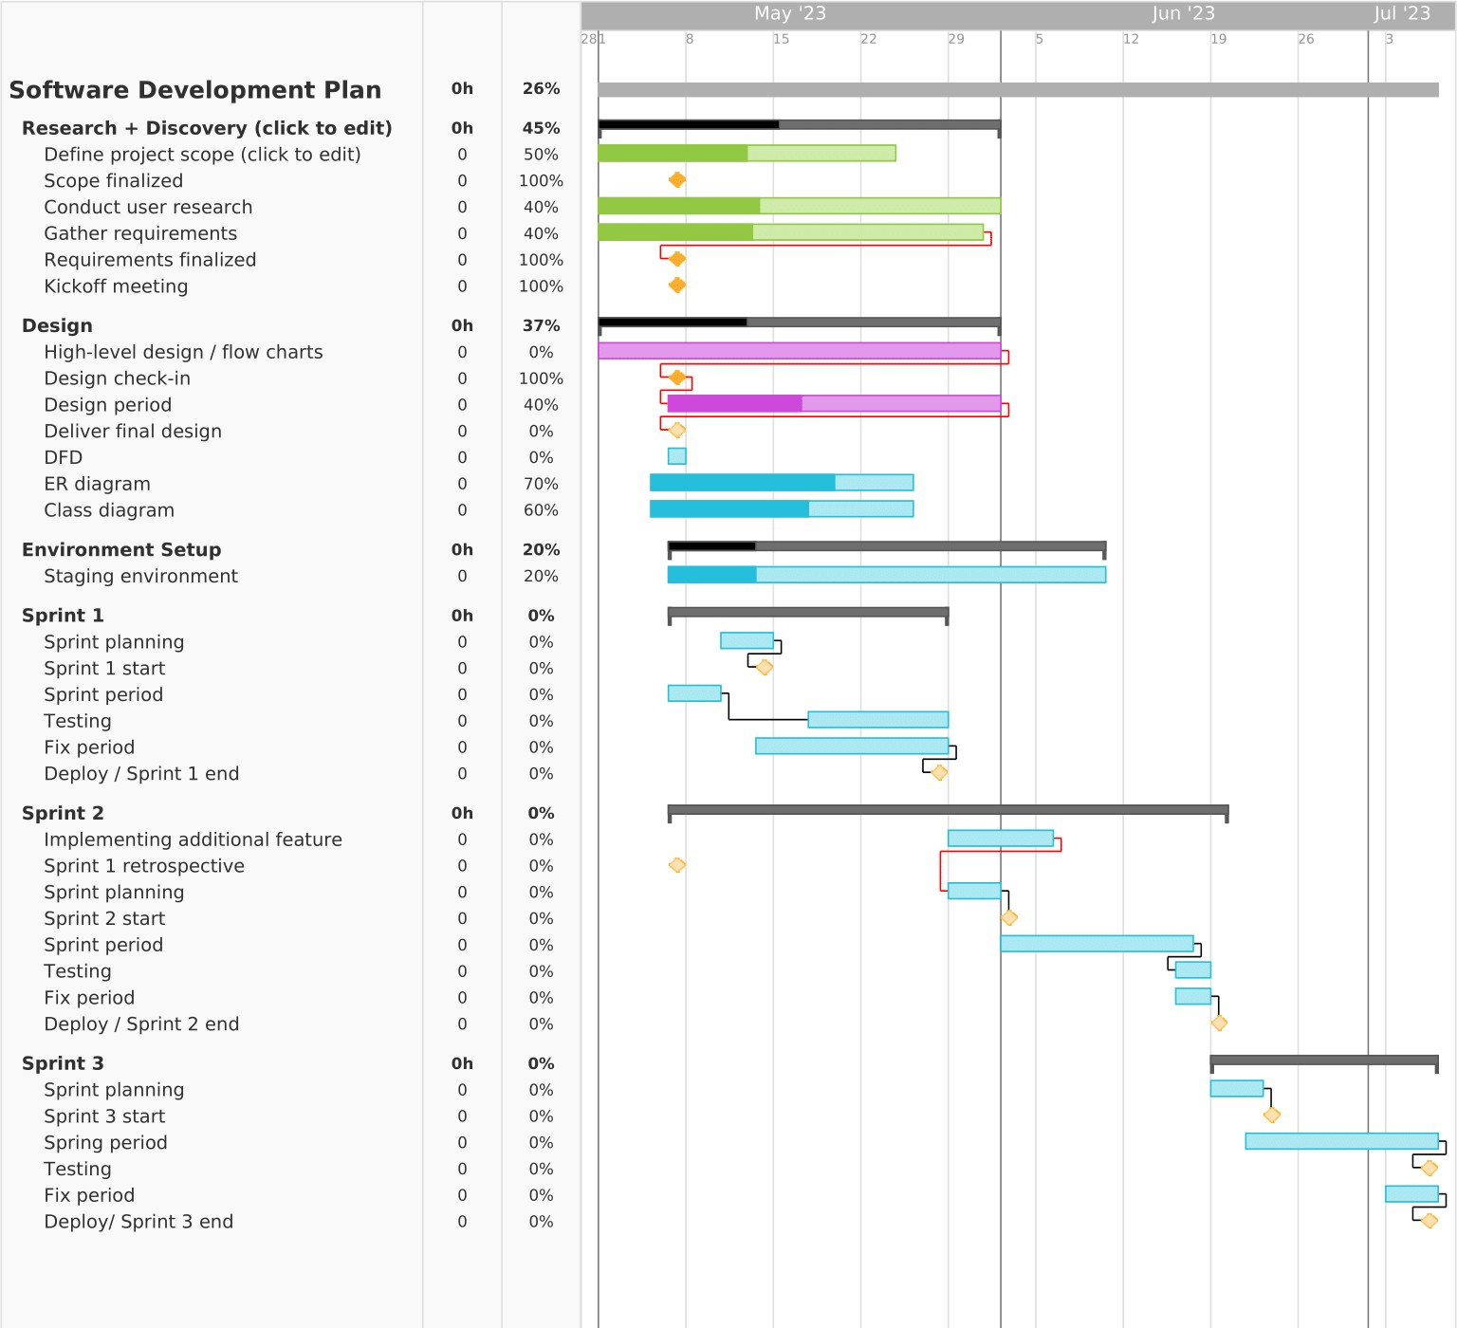

Figure 6. 1 Gantt Chart

# Deliverables

Once the app is created, there are certain criteria it will fulfill in order to be successful. Although the system is never fully perfect and there is always room for improvement. There are some things that are basically expected after a system is created. Some of our targeted and expected output are:

* It will provide a platform for individuals who have mental stress and looking for someone to share their problems and stress
* It will be able to track the mood of the users and analyze their mood over a specific time and recommend workouts and exercises.
* It will also provide user guide for those who are new to the app.
* It will provide a community driven platform top share the experience of the user with other users of the app.
* It will provide doctors information based on the analysis of users issue.

# References

*Chat GPT*. (n.d.). Retrieved from Chat GPT: https://chat.openai.com/

Dorwart, L. (2023, 04 19). *Best Mental health App*. Retrieved from Verywell mind: https:/[/www.ve](http://www.verywellmind.com/best-mental-health-apps-4692902)r[ywellmind.com/best-mental-health-apps-4692902](http://www.verywellmind.com/best-mental-health-apps-4692902)

*Mood Analyzer*. (n.d.). Retrieved from Devpost: https://devpost.com/software/moodanalyzer

*Mood fit*. (n.d.). Retrieved from Mood fit: https://[www.getmoodfit.com/](http://www.getmoodfit.com/)

*Wysa*. (n.d.). Retrieved from Wysa: https://[www.wysa.com/](http://www.wysa.com/)